**Part1**

Please return SQL scripts and results of the queries for the following questions.

1. Return the FirstName, and LastName of the Customers who have not made a Purchase in the last 6 months of 2016 (July-December):

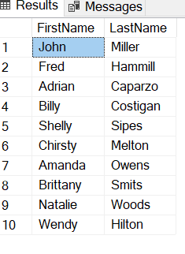

1. Return the ProductCategory and the average PurchasePrice for all customers who have purchased three or more unique products.

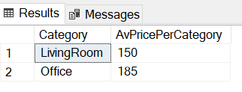

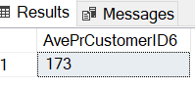

1. For each product Category, return the top 2 customers’ ID and name based on total sales.

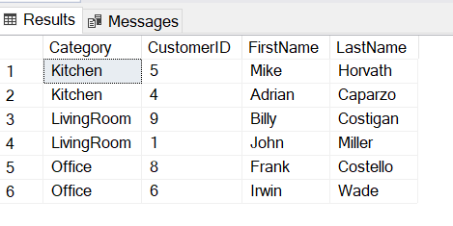

**Part 2**

Using any data visualization tool or method that you are comfortable with, create a visualization to compare sales by product category between the first and second half of the year (January-June vs July-December).

<https://public.tableau.com/views/RoswellInterview/Dashboard1?:language=en-US&:display_count=n&:origin=viz_share_link>

